Library Name: | cgm
Cell Name: | AOI3
Function/Truth Table: Y = $\overline{(B+C).A}$
A B C |  | Y
0 0 0 |  | 1
0 0 1 |  | 1
0 1 0 |  | 1
0 1 1 |  | 1
1 0 0 |  | 1
1 0 1 |  | 0
1 1 0 |  | 0
1 1 1 |  | 0
Propagation Delay (path based):
Transition |  | Delay (s)
A → Y ↑ (T_PLH) |  | 1.161n
A → Y ↓ (T_PHL) |  | 1.422n
B → Y ↑ (T_PLH) |  | 1.283n
B → Y ↓ (T_PHL) |  | 1.777n
C → Y ↑ (T_PLH) |  | 1.281n
C → Y ↓ (T_PHL) |  | 1.787n
Output Rise Time (path based):
Transition |  | Rise Time (s)
A → Y ↑ |  | 2.308n
B → Y ↑ |  | 2.472n
C → Y ↑ |  | 2.475n
Output Fall Time (path based):
Transition |  | Fall Time (s)
A → Y ↓ |  | 2.627n
B → Y ↓ |  | 3.369n
C → Y ↓ |  | 3.423n
Layout Height:
Layout Width:
Layout Area:
Symbol with Port Names:

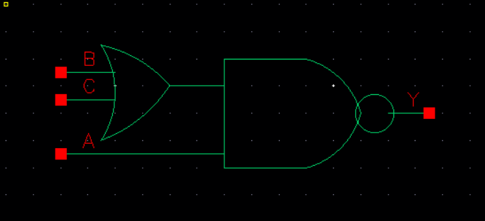
Schematic:

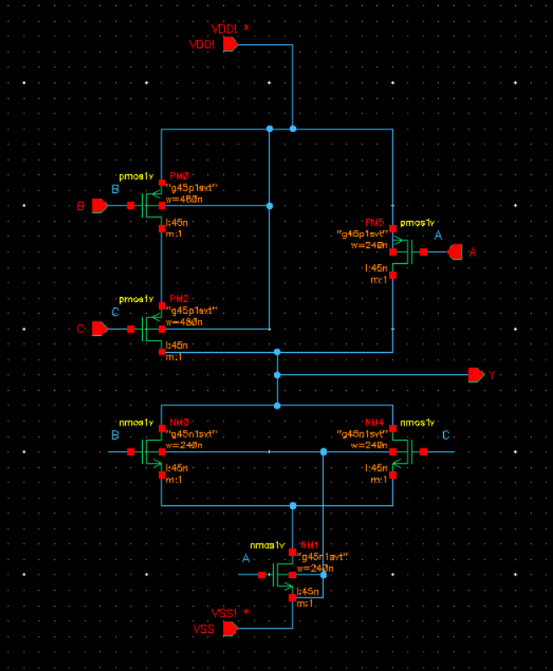
Layout:
Functional Simulation Waveforms

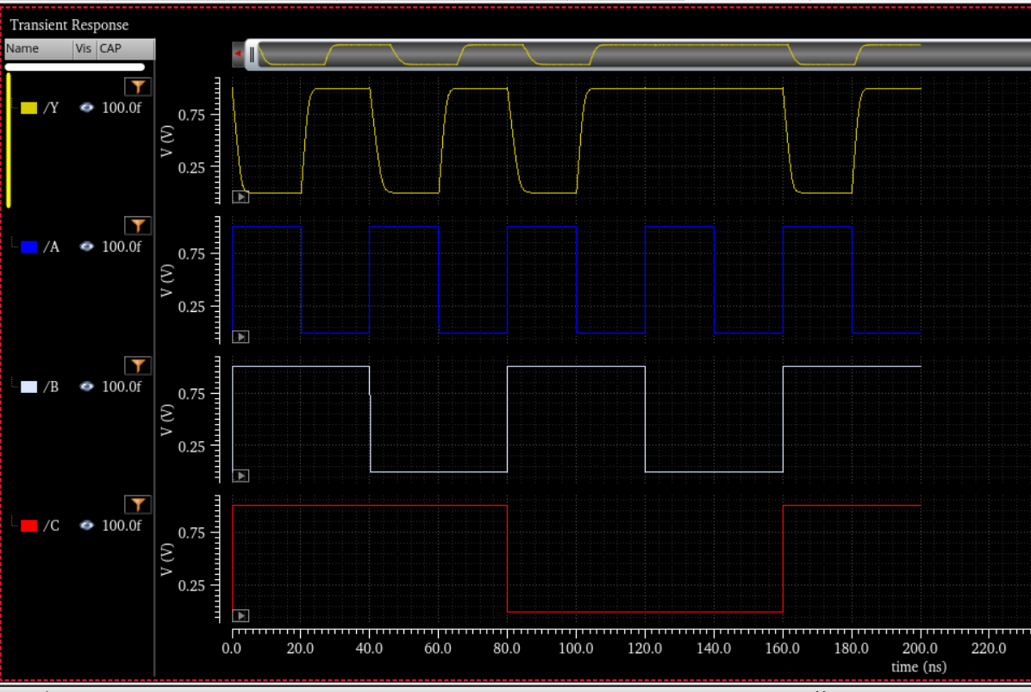

Comments/Notes:

The AOI3 (AND-OR-INVERT) gate was successfully tested, with correct functional verification. Propagation delays and rise/fall times were measured and are consistent with the expected AOI3 behavior. The gate meets performance requirements, with fall times slightly longer than rise times, which is expected due to transistor sizing and load capacitance effects.

